**Team Members: Personal Information**

Name: Yujia Deng, Hyun Jun Choi, Ang Mai

Address: University of Southern California, Los Angeles, CA 90084

Email: [yujiaden@usc.edu](mailto:yujiaden@usc.edu), [choi797@usc.edu](mailto:choi797@usc.edu), [angmai@usc.edu](mailto:angmai@usc.edu)

**Project Information**

Project Title: Predict Graft Survival after OLT using Pre-Transplant Features

Date Started: 1/11/2018

Date Completed: 5/3/2018

Project Sponsor/Champion: Professor Anna Farzindar

**Executive Summary**

This project aims at the problem of identifying features associated with and predicting graft survival after OLT.

In of the scope of the project includes data obtaining and studying, data analysis and presentation to stakeholders. Out of the scope is data collection and data publication.

Project milestones were set and achieved each month. Based on the Lean Six Sigma, we built five phases of the project. The first phase is defining project goals, customer deliverables and other project details by using project charter and SIPOC diagram ending in early March. Then the second phase is measuring performance by using process mapping and start developing statistical analysis ending in early April. The third phase is analyzing causes of bad performing or overfitting models and comparing models ending in mid April. Next, the fourth phase is improving model performance by using other methods and developing other potential solutions for bad performing models ending in late April. Last but not least, the fifth phase is controlling project performance by finalizing reports and PowerPoint presentation to stakeholders and finishing end product ending in early May.

The end product is a website containing information about data exploration and prediction, and it has been tested multiple times and is only accepted when all functions work properly including contents built with Tableau and R. Analysis of the data leads to the conclusion that there are certain variables that are significantly associated with graft survival while some are not, and the recommendation for patients, doctors, and relating experts in the field to use the prediction tool for graft survival after a donor-recipient pair has been formed.

Tasks completed during the projects include obtaining and studying the dataset and background information, analyzing data consisting of data cleaning, using different approaches for analysis, evaluating performance of models, and transforming results into easy-to-understand messages through presentation and website. Classification models were trained and tested to measure performance while regression and survival analysis models were checked using performance measurement such as R2, AIC and C-Index. After the comparison of the information conveyed by different models, survival analysis is selected for building the prediction tool. With the tool, patients and doctors will benefit from being able to predict graft survival for each new patient at different future timeframes up to about 4000 days and therefore can make more informed decisions about the surgery accordingly.

**Lean Six Sigma Project**

**Define Phase**

Cost of Poor Quality Statement

According to the data from American Liver Foundation, each year in the U.S., around 6,000 recipients have benefited from liver transplant.[1] The number of liver transplants has been increasing annually, however, in contrast with the rapid increase of the liver demand, there is a severe shortage of liver donors and the success of the surgery is not guaranteed. 8,082 liver transplants were performed in 2017 and 13,869 patients are still waiting for a liver as of Jan 2018, and graft failure accounts for about 20% of death in one month after the surgery from 2010 to 2015.[2]

Therefore, it is extremely important to undergo careful evaluations before deciding the operation of transplant to avoid futility and waste of resources for an unlikely successful surgery. The opportunity of the project is to explore the possibility of applying data analysis to help doctors and patients make more informed decision prior to orthotopic liver transplant (OLT).

Customer Satisfaction (Voice of the Customer)

A poor quality end product impacts customer’s usage and therefore the value of the project. A website containing data exploration and prediction tools, the end product should be aesthetically viewable, conveniently accessible, and easily navigated. Customers should also be granted authorizations to access the private contents on the website.

The voice of customer is tested during the demonstration of the end product and validated when the customer understands how to navigate within the website, explore data, and use the prediction tool without any issues.

Tools Application

Python and R are used in building models. During the process, we have learned how to build support vector machine (SVM) and neural network (NN) models for classification in Python, use subset selection methods in R and develop cox regression model in R. Tableau is used to build data visualization and we have gained knowledge in using the tool. We have also learned how to use Shiny in R to build online applications that can be used for data exploration and prediction. Our learning experience also includes building a website using Google Sites with functions of embedding contents from Tableau and Shiny apps.

**Measure Phase**

Process Mapping/Process Visualization

Different levels of process maps have been developed during the project. A high level process map describes supplier, inputs, process, outputs, and customers and is abbreviated as SIPOC. A more detailed process map is the common process map, outlining the main tasks in the project. Detailed process map is the most detailed, including both main processes and their sub-processes. Last but not least, a functional process map is created to easily visualize people responsible for each process and the corresponding function. Please see the Appendix A for the process maps.

The Vital Few

This project aims at the problem of identifying features associated with graft survival after OLT. The vital few covariates contributing to the response, graft survival, are selected using different methods, including boosting decision tree, subset selection and purposeful selection based on significance and model performance. More details are outlined in the “Result and System Implementation” section.

Data Collection Planning and Execution

Data collection is out of scope and the data is provided by the Department of Surgery at Keck Medicine of USC. The dataset contains 84603 observations of 159 variables. The first step in data preprocessing is to remove invalid observations, whose graft survival time is larger than patient survival time, and useless variables, post-transplant features. Then the process includes checking missing values and determining imputing methods. If a categorical variable has an originally defined unknown category, missing values are assigned to the category; if not, then proportion of missing values is checked and if larger than 0.05, an unknown category is created for the missing values, if less than or equal to 0.05, missing values are assigned the mode.[3] For continuous variables, predictive mean matching is used in implementing the missing values. Data preprocessing lead to a dataset of 42169 observations of 145 variables useful for regression and survival analysis in addition to graft status (GSTATUS) and graft survival time (GTIME).

For classification, new datasets are subsetted from the dataset after imputation based on graft failure time. Then, censored data including the observations whose graft status is alive but graft survival time is less than the time of interest are removed. The following step is to create a new indicator variable of the time of interest. For example, when creating a dataset to analyze graft survival within one month, observations whose graft status is alive and graft survival time is less than 30 days are removed, then an indicator variable G30 is created and assigned value 1 if the graft survival time is greater than or equal to 30 days and assigned value 0 if the graft survival time is less than 30 days. As we are interested in analyzing graft status in 1 month, 2 months, 3 months, 6 months, 9 months, and 1 year, 6 subsetted datasets are created, each with a corresponding new indicator variable.

Measurement System Analysis

Measurement system analysis is performed to analyze the stability, bias, linearity, repeatability, and/or reproducibility of a measurement system.[4] In the project, the measurement system measures the performance of models developed for data analysis, and the measurement system analysis focuses on measuring the stability of model performance. Reference model performance comes from current studies, which is about 66.2% accuracy of classifying graft status after the surgery.[5]

Measurement system analysis looks at the multiple models implemented and records the test accuracy for each models, revealing that most of the models achieve reasonable accuracy below the reference line.

Tools Application

Flowchart tools are used in the process of creating process maps, and Google Slide is used to recreate the process maps for them to be presentable. Performance metrics are defined based on literatures and current studies in the field, including AUC-ROC (measures classification accuracy) for classification models, R2  (measures amount of variation in the dependent variable accounted by the independent variables) and AIC (measures the amount of information lost) for regression models and C-Index (analogous to AUC-ROC) for cox regression models. Knowledge in accessing the performance of machine learning and statistical models are gained throughout the process.

**Analysis Phase**

Charts that Help Analyze Data Collected From the Measure Phase

In order to identify the variables related to graft survival after OLT, in addition to focusing on the short-term graft survival, it is useful to gain a understanding of long-term graft survival rate, whose causes are analyzed using fishbone diagram as shown in Appendix B.

Additional Charts used by Lean Six Sigma

In addition to fishbone diagram, a work breakdown structure (WBS) is created to effectively organize the team’s work into manageable tasks, as shown in Appendix B.

Y=f(X) Formula

In the process of identifying important variables associated with graft survival, the outcome of potential solutions is a list of variables that are selected as important for graft survival; the inputs to achieve the outcome are all available useful features from the dataset, and the inputs are put into different models to achieve the outcome.

In classification, boosted decision tree is used to select top features to be used in SVM and NN models. The process can be formulated as $Selected features=Boosted Decision Tree (Available useful variables)$.

In regression, backward selection is used to select a linear regression model. The process starts with $GTIME = β_{0}+β_{1}X_{1}+β_{2}X_{2}+...+β_{k}X_{k}+ε$, where k is the greatest possible number, i.e. all available useful variables, and ends when an optimal model is achieved with lowest AIC score. The process can be formulated as $X's in selected model=Backward selection (Available useful variables)$

In cox regression, variables are selected in a purposeful mechanism outlined in more detail in the “Result and System Implementation” section. Cox regression model can be formulated as $h(t | X)=h(t |X=0)exp(β_{1}X_{1}+β_{2}X_{2}+...+β_{k}X_{k})$ and the feature selection process can be formulated as $X's in final cox regression model= Purposeful selection (Available useful variables)$

Strengths, Weaknesses, Opportunities, and Threats

Strengths of our team includes statistical backgrounds of the teammates as two of us major in Statistics. We are also good at making aesthetic visualizations using various tools and aim at creating neat, visually enjoyable and powerful presentations.

With a background focusing on data analytics and statistics, our team is not strong at coding and integrating codes written in different platforms including R and Python. We also should avoid switching goals in the middle of the project as new ideas appear but instead perform more research at the early stage to finalize a goal that we will work on throughout the project.

As the need of liver is increasing consistently, there are numerous opportunities to perform data analysis and use the results to help doctor and patients make better decisions of the surgery, as well as help patients survive longer after the surgery, and ideally reduce liver-related diseases and therefore reduce the need of liver transplant.

However, environmental degradation heavily influences people’s health. The advance of medicine and technology might help cure many diseases nowadays, but not all diseases are curable. The bad habits that people have in their lives also posed threats to their health, making it harder to reduce the need of certain medications and surgeries, including liver transplant.

Root Causes

The fishbone diagram is used to analyze long-term low graft survival rate. To analyze short-term graft survival, we plot the graft survival rate in 1 month, 2 months, 3 months, 6 months, 9 months, and 1 year and also explore the data by gender, age group, and blood type in Appendix C. Graft seems to be able to survive at least 80% of the time under 1 year and the trend seems smooth and there are indeed differences of people having different biological characteristics, so the reason for decreasing graft survival might relate to the degradation of the graft functions as time passes and the biological factors.

Correlation

By examining the scatter plots between graft survival time and each feature, there seem not to be any obvious correlation between graft survival time and any individual feature. Correlation plots of continuous variables are also created, and no hidden correlation is identified other than repetitive measures such as weight at transplant and weight at registration. Please see Appendix C for the plots.

Sources of Variation

Model performance varies as we perform cross-validation and/or tune models by adding or removing variables used in the analysis. Classification models’ performance metrics such as area under the receiver operating characteristic curve (AUC-ROC), true positive rate, false positive rate, positive predictive value, F1-score, R2, AIC and C-Index all vary as the number of variables included in multivariate models changes.

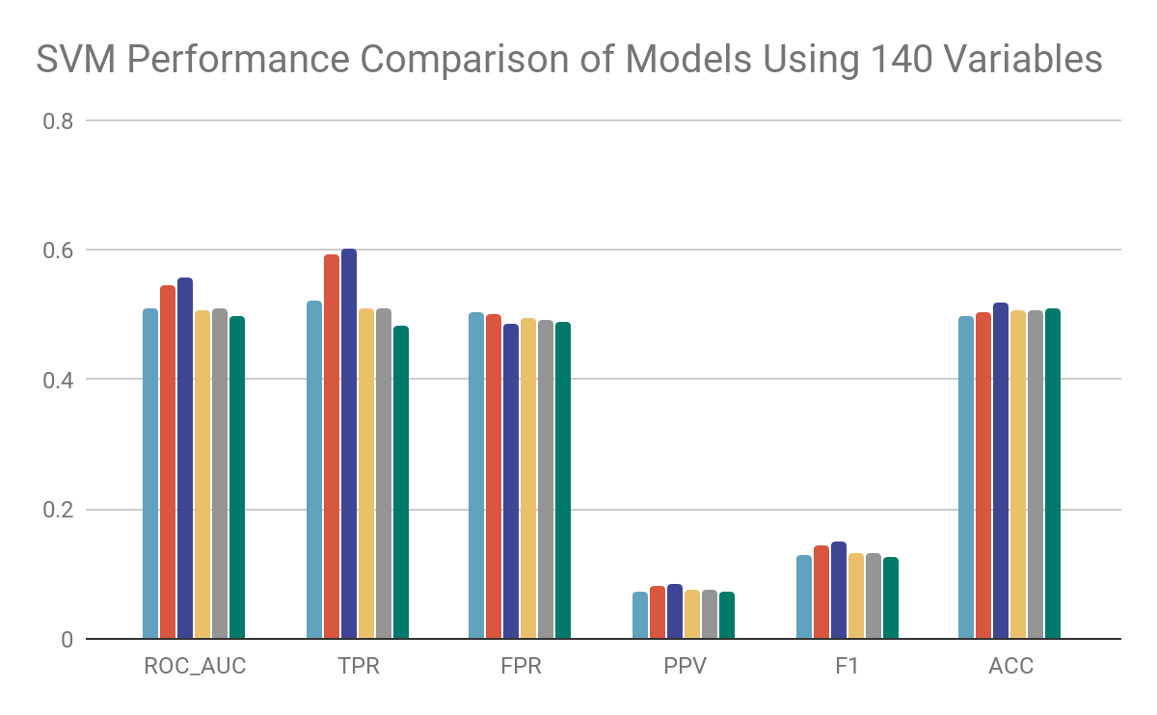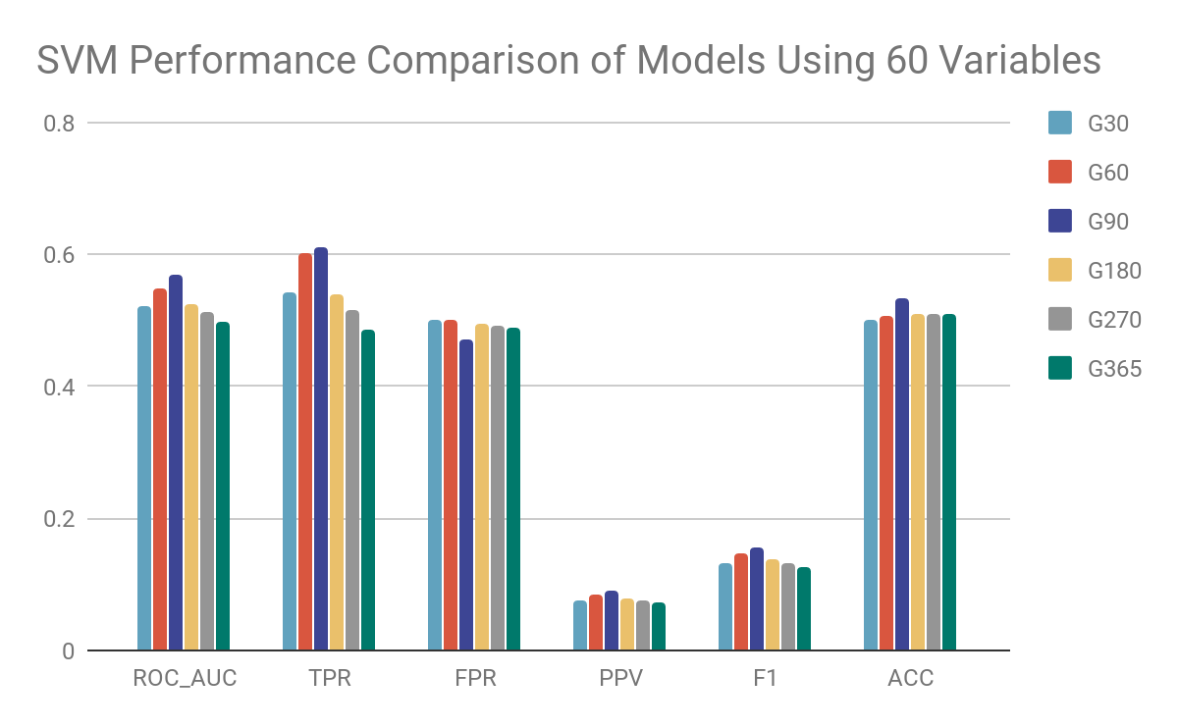

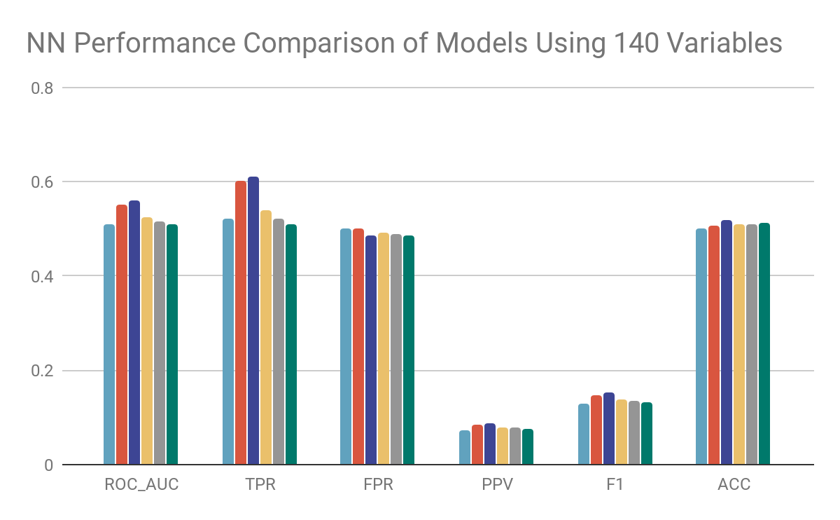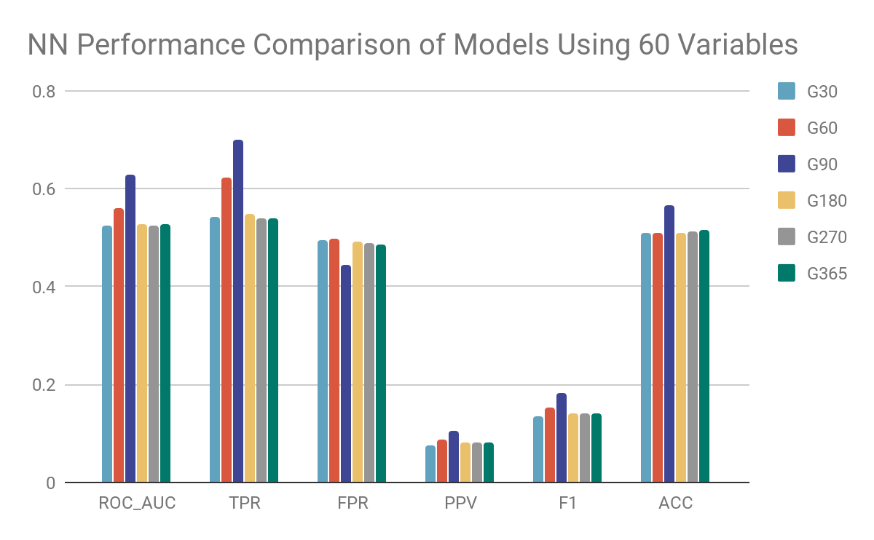

*Figure 1. Graphs showing performance metrics of classification models. Variation is visible as number of variables used changes.*

Potential Solutions

To identify important features related to graft survival, one potential way is to use tree-based methods to select the features. Boosted decision tree is implemented to select the top features for predicting graft survival in six different time frames under one year. Among the six selections, many donor-related variables appear multiple times to be on top of the list. Subset selection is another potential solution to identify important variables in linear regression model attempting to predict graft survival time. Purposeful selection can also be a solution to find out features related to graft survival in cox regression.

**Improve Phase**

Alternative Solutions Considered

For linear regression models, an alternative selection method can be separating the data by age group so different analyses are performed for MELD or PELD score.

The selection method in cox regression includes fitting univariate models and then multivariate model of significant variables in univariate analysis. To improve it, categorical variables with too many levels that might lead to errors in the model should be removed.

Another solution is in addition to the above steps, the multivariate models can be further tuned by adding variables of interest such as blood type, age, gender, and state of residency.

Please see Appendix D for the variables selected in classification, linear regression and cox regression after performing improvement and comparing the solutions.

Recommended Solution(s)

After comparing the models based on their model performance and amount of information conveyed, the cox regression model is selected as the recommended solution to build a prediction tool for graft survival. Cox regression can predict the probability of experiencing graft failure at time t+1 assuming the graft has survived until time t. One concern is that there are time-varying variables included in the data set such as the number of previous transplant, without adjusting the model to incorporate the time-varying effect, the model’s accuracy might not be as high. Overall, the model has accuracy 0.583.

Ways to Pilot the Recommended Solution(s)

The solution is tested by inputting new values of the variables used in the model and checking the prediction. Predicted probability of graft survival should not be higher than 1 and lower than 0. Reasonable values should be close to the survival rate from data exploration, which shows that the average is about 0.89.

Project Plan

A WBS is created specifically for the recommended solution.

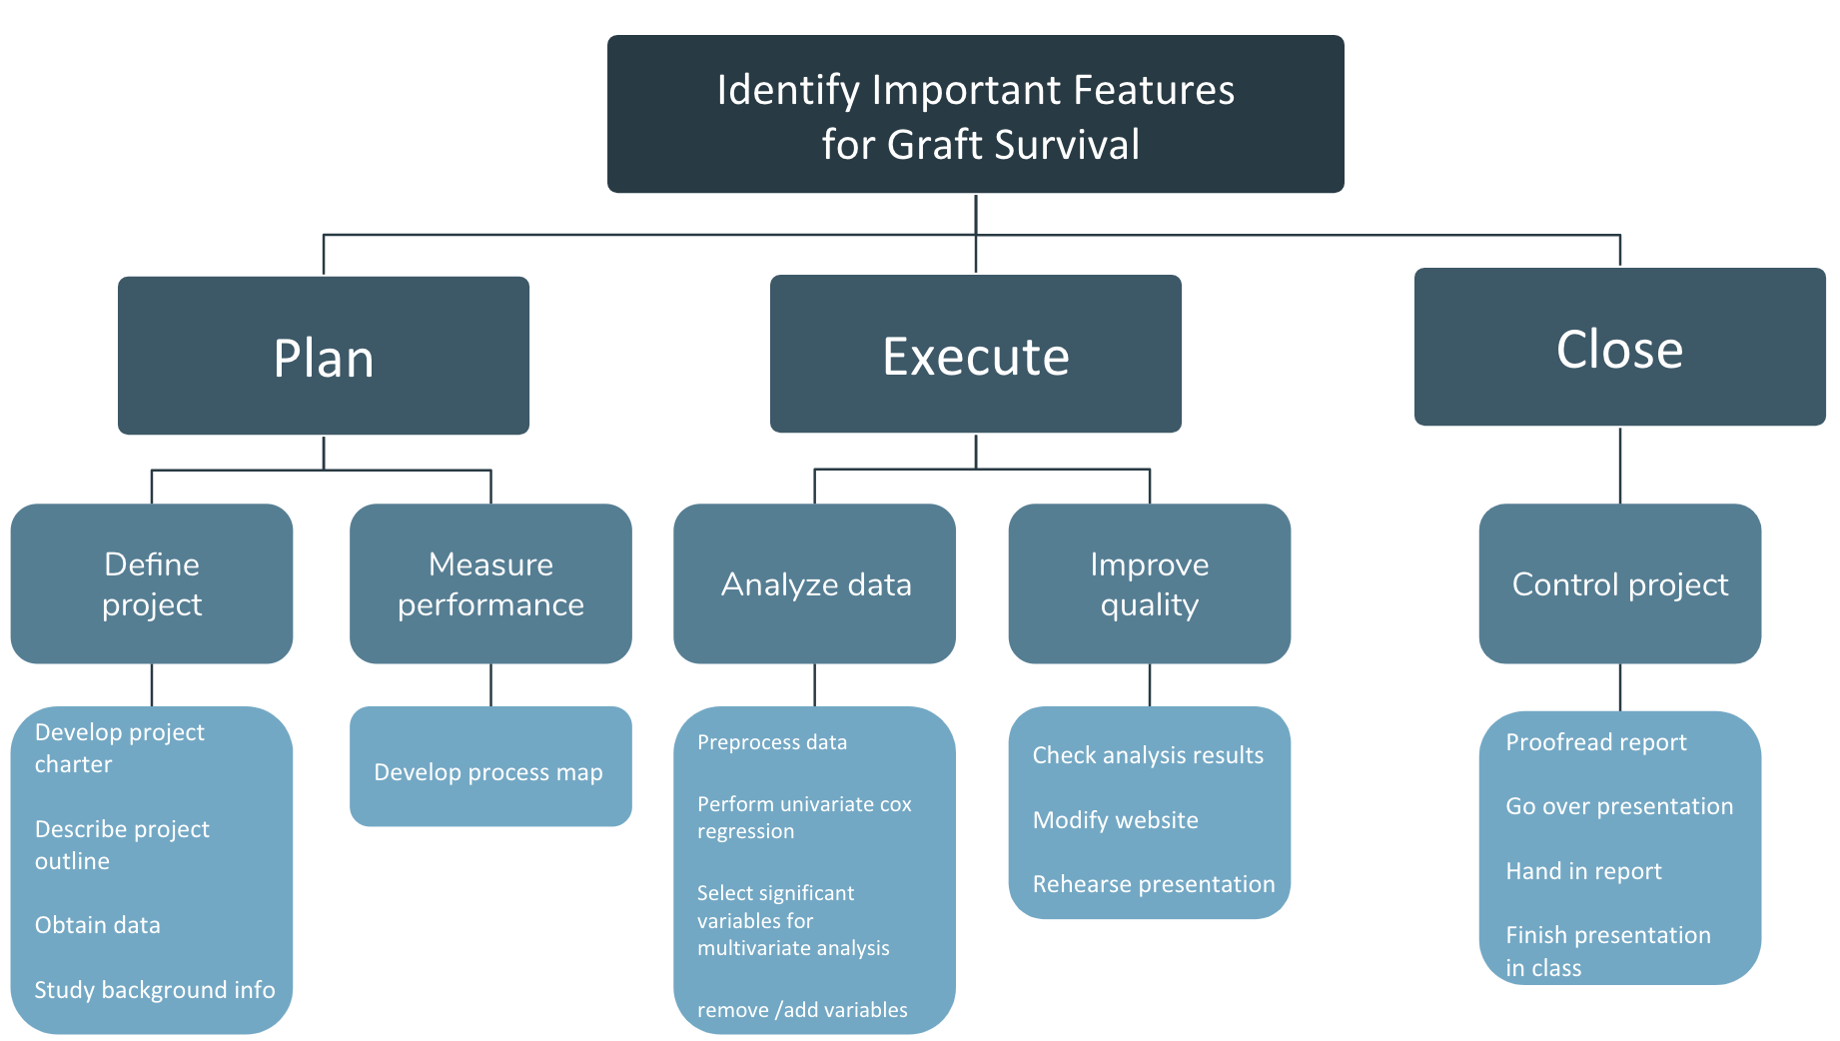

*Figure 2. Work Breakdown Structure for developing prediction tool using cox regression.*

**Control Phase**

The project is controlled by weekly meetings with the teaching assistant at the latter half of the semester and regular weekly or bi-weekly team meetings throughout the semester. Day-to-day processes are controlled by live communication among teammates, updating tasks done or difficulties encountered, and the issues would be discussed in the next team meeting. The Gantt chart is also used as a control tool to keep up with the schedule as shown in Appendix B.

One challenge in implementing control is coming up with new ideas and still following the Gantt Chart. Therefore, we need to adjust the Gantt Chart to extend the define and analysis processes, but also need to make sure we still meet the deadline of closing the project.

After closing the project, we will communicate with the customers to add authorized users as desired. We will also maintain the website and the contents on the site. If the customers have any questions, we will also be available through email posted on the website.

**Result and System Implementation**

**Machine Learning Approaches**

**Classification**

**1. Neural Network (NN)**

NN is a supervised machine learning algorithm that learns a function by training on a dataset. With a set of features and an output, the model can be trained as a classification model. Between input and output, there are hidden layers in the model.

Two of the parameters in NN is epoch, number of forward and backward passes of all training examples, and batch size, the number of training examples in one forward/backward pass.[6] Different values of epoch and batch size are checked and the optimal test performance and computing time are reached at epoch 300 and batch size 200.

For each of the 6 subsetted data sets, boosted decision tree is implemented to select top features that will be later used in the NN classification model. 20% of data are separated as test set. Models are trained and validated on the other 80% of the data using 10-fold cross validation, and then tested on the test set. Data are also oversampled to fix the unbalanced class problem, as proportion of observations with alive graft is much higher than observations with dead graft. Performance metrics are outputted for comparison. On average, NN is able to reach about 50% of AUC-ROC.

More details regarding NN can be found in Appendix E.

**2. Support Vector Machine (SVM)**

SVM is a supervised machine learning classifier. Given a set of labeled features and an output, the algorithm outputs an optimal hyperplane that categorizes new observations.[7]

The kernel function is used to study the type of relationships in data, and needs to be chosen with consideration as the data is not linearly separable.[8] Another parameter is gamma, which indicates how far the influence of a single training observation can reach.[9] The radial basis function is used as the Kernel function and 10 the gamma.

20% of data are separated as test set. Models are trained and validated on the other 80% of the data using 10-fold cross validation, and then tested on the test set. Data are also oversampled to fix the unbalanced class problem, as proportion of observations with alive graft is much higher than observations with dead graft. Performance metrics are outputted for comparison. SVM is performed on each of the 6 subsetted data sets, and reaches AUC-ROC at about 50%.

More details regarding SVM can be found in Appendix F.

**3. Comparison**

Overall, both models achieve AUC-ROC about 0.53 on average predicting graft status over different time frames up to 1 year after the surgery. Compared to SVM, NN seems to perform better overall in G90. In G90 prediction, the AUC of NN is 0.62 and that of SVM is 0.56.

**Linear Regression**

A linear regression is modeled as $GTIME = β_{0}+β_{1}X_{1}+β_{2}X_{2}+...+β_{k}X_{k}+ε$,

$k=145$ as there are 145 features available for analysis after data cleaning. Backward selection is used, taking the full model with all features as the start, and remove one variable each time to achieve optimal AIC.

The parameters $β_{i}$ are estimated using ordinary least square, which is minimizing the sum of squares of the differences between the observed GTIME and the predicted values by the linear function. The coefficient estimates of $β_{i}$ represent the magnitude of association between the corresponding X and GTIME while all the other variables are constant.

The baseline model has AIC 570831.1 and the selected model has AIC 569712.5. R2 is 0.027. New values of the independent variables can be inputted and a predicted GTIME will be outputted.

Linear regression model assumes linearity, normality, and homoscedasticity (equal variances) and the assumptions are checked using residual plots and the linearity and homoscedasticity assumptions are violated as shown in Appendix G.

**Survival Analysis**

Survival analysis is performed using cox regression, which is modeled as $h(t | X)=h(t |X=0)exp(β_{1}X_{1}+β_{2}X_{2}+...+β_{k}X_{k})$. $h(t | X)$ is the hazard function given a set of features X, which can be understood as the probability of an individual experiencing graft failure at time t+1 if the person has survived until time t. In the final model, $k=17$.

The parameters $β_{i}$ are estimated using partial maximum likelihood. The exponential of the coefficient estimate represents the effect of the corresponding feature has on the ratio of two hazard function while all the other variables are constant. For example, for continuous variable, the hazard ratio between people whose $X_{i}=x+1$ and people whose $X_{i}=x$ is exp($β_{i}$) , meaning that people whose $X_{i}=x+1$ is exp($β_{i}$) times more likely than people whose $X_{i}=x$ to experience graft failure while all other variables are the same; for categorical variables, the hazard ratio between people of category $j$ and people of baseline model $l$ is exp($β_{j}-β_{l}$), meaning that people of category $j$ is exp($β_{j}-β_{l}$) times more likely than people of baseline model $l$ to experience graft failure while all other variables are the same.[10]

The model achieves C-index 0.583. New values of the independent variables can be inputted and the model will output a predicted hazard function.

Cox regression assumes proportional hazard and linearity. The assumptions are tested in the cph.zh function in R using chi-square test. Significant test (p-value<0.05) indicates non-linearity and except for one level in the state of residency variable everything else is non-significant, so the model assumptions can be said to be met as shown in Appendix H.

**System Implementation**

After evaluating the performance, assumptions and amount of information conveyed by different models, survival analysis is selected for building the prediction tool as the cox regression seems to meet the assumptions and is able to predict the hazard function of time in addition to merely the graft survival time in linear regression or the graft survival status in classification.

The selected cox regression model is incorporated into a Shiny app written in R. Users will be able to input new values of the independent variables in the model in the app. A graph of the hazard function will be plotted with time on the x-axis and survival probability on the y-axis, and survival probability at times of interest include 1 month, 2 months, 3 months, 6 months, 9 months and 1 year will be shown as shown in Appendix H. 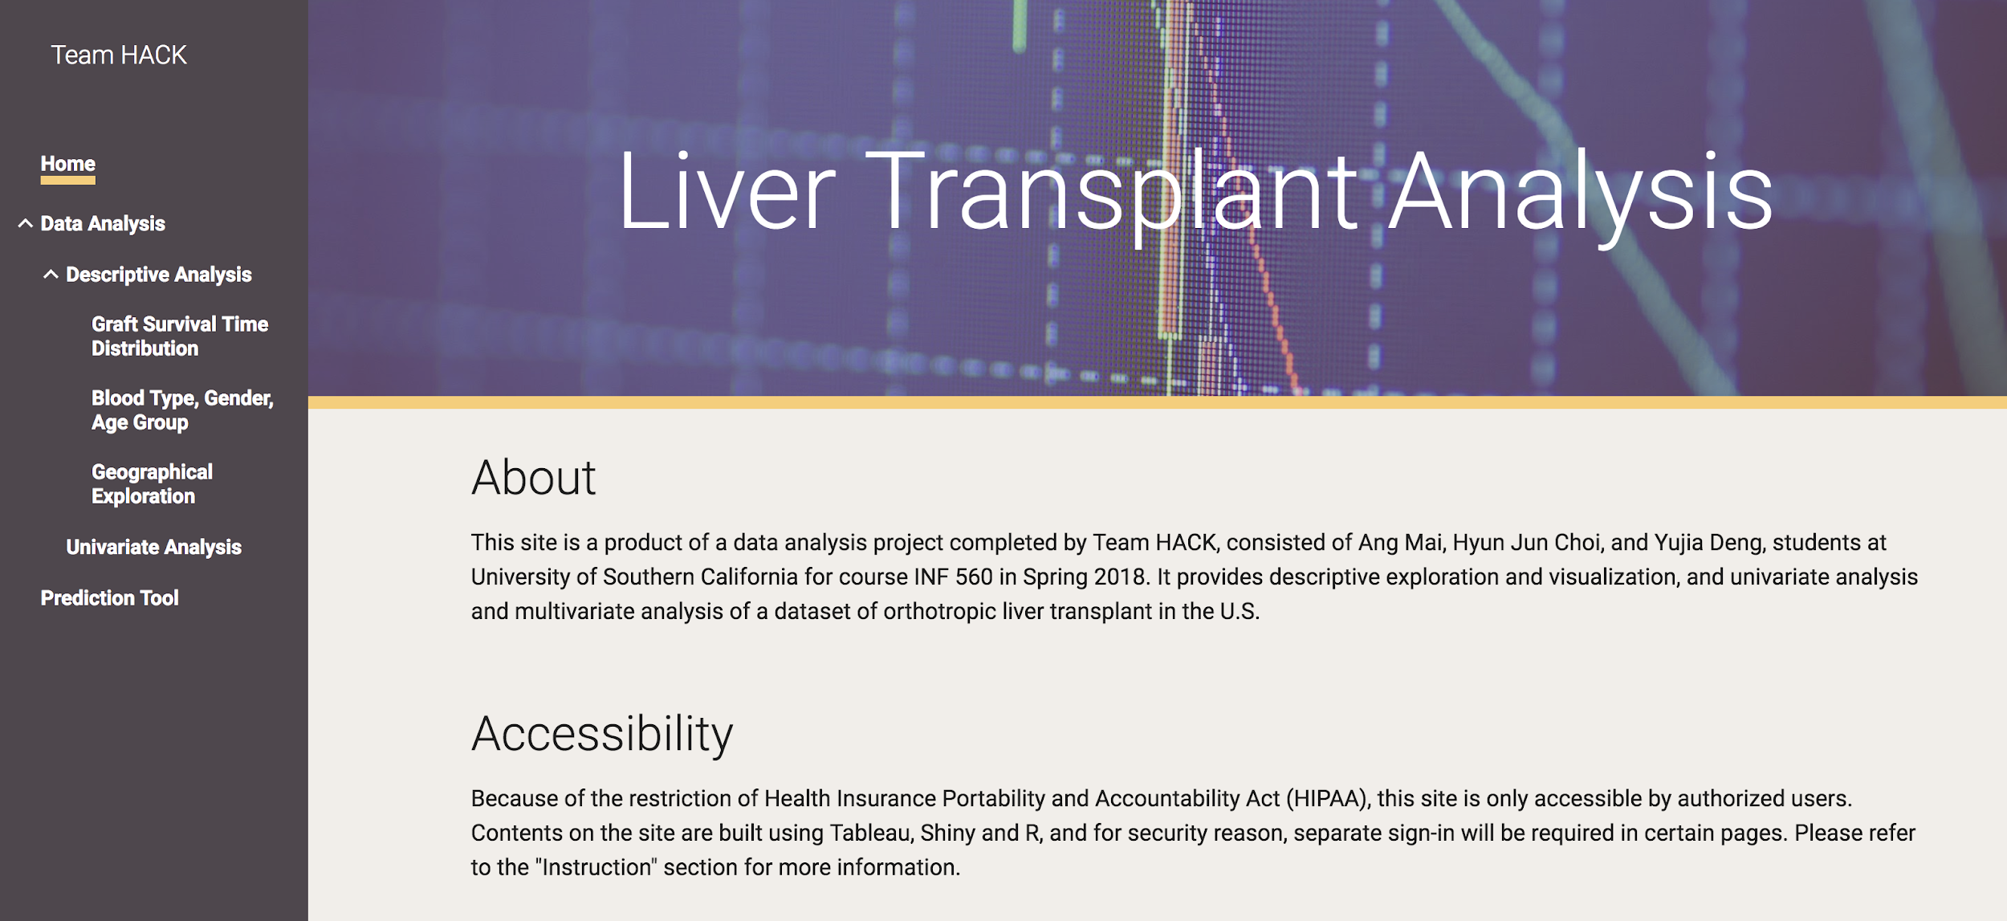

**Prototype and Demo**

A prototype of the end product is a website where users can navigate for data analysis tool and prediction tool. Tableau and Shiny in R are used to develop contents on the site as well. *Figure 3. Page of Website presenting analysis results and tools*

To ensure security of the information, the website is only accessible by authorized users. To view the contents on built with Tableau and Shiny, additional authorizations need to be granted. To fully access the site, there are 3 authorizations needed to be granted.

1. Access to the site
2. Access to the Tableau contents in the site
3. Access to certain Shiny contents in the site

Customers can communicate with us for adding authorized users.

The menu is located on the left. The home page includes information about the website including instructions on accessing the contents and contact information. Under “Data Analysis”, users can explore the data in the “Descriptive Analysis” section the distribution of graft survival time, graft survival statistics by blood type, age group, and gender, and geographical exploration. To assess the relationship between graft survival time and any other variables, users can log in to “Univariate Analysis” to check out the scatter plot, Kaplan-Meier curves, and survival curve outputted by univariate cox regression between GTIME and one of the independent features by selecting GTIME as the “Y Feature” and the desired independent feature as the “X Feature”. Users can also choose to visualize the correlation between any two variables by selecting the desired “Y Feature” and “X Feature”. In the prediction tool, users input values of the variables on the left and on the right the app will output a survival curve and underneath survival probability at different times of interest.

**Appendix A**

**Different Process Maps**

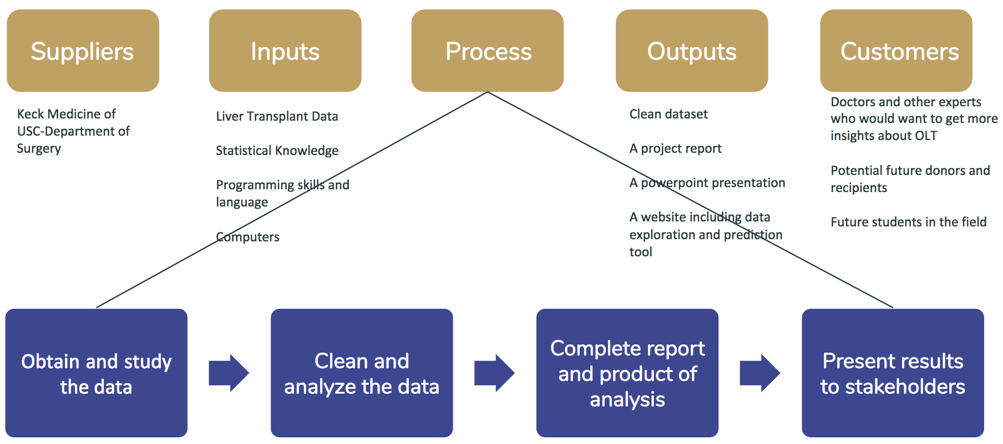

*Figure A1. SIPOC.*

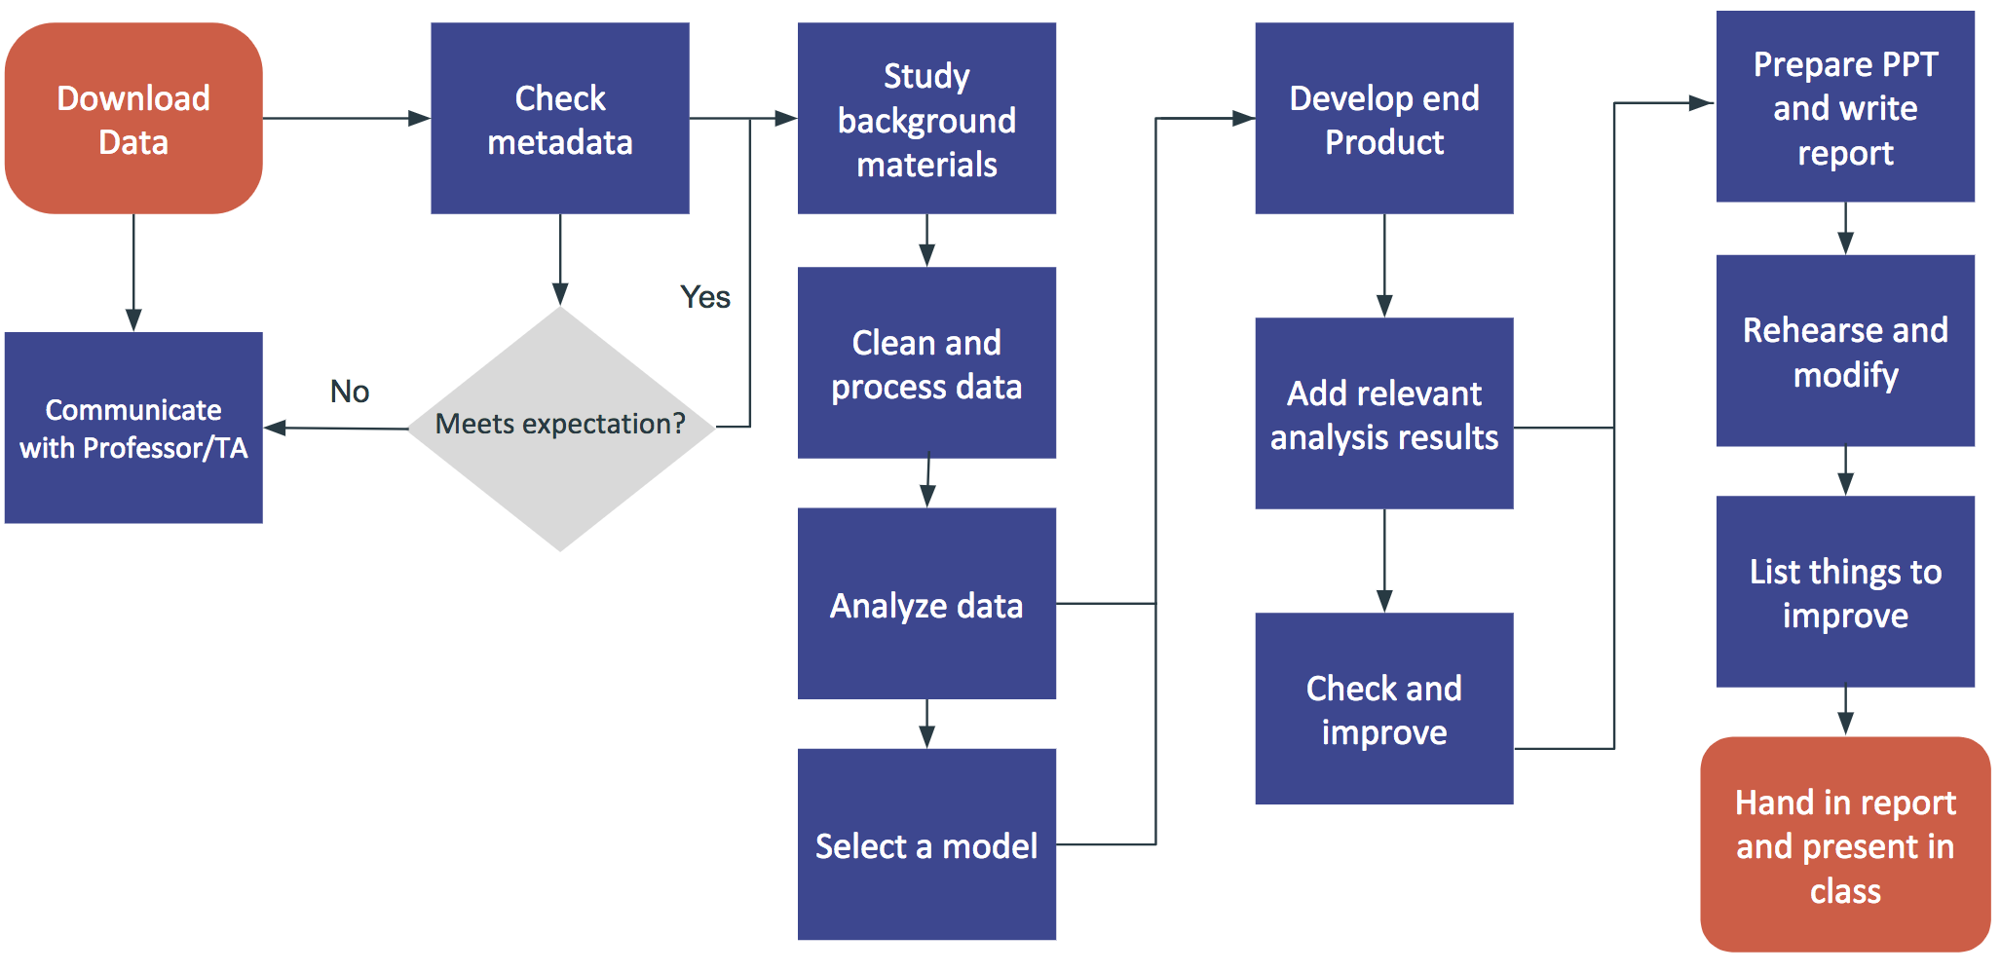

*Figure A2. Common Process Map.*

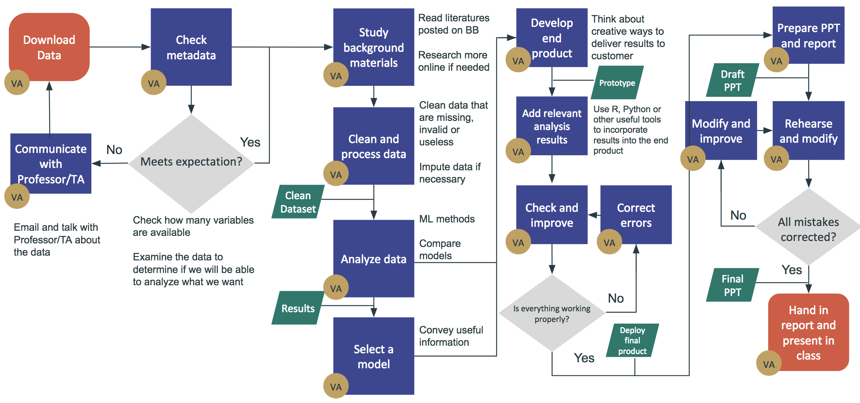

*Figure A3. Detailed Process Map.*

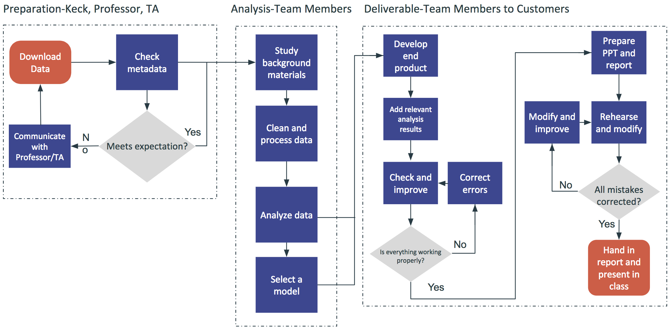

*Figure A4. Functional Process Map.*

**Appendix B**

**Other Charts/Graphs used in Lean Six Sigma**

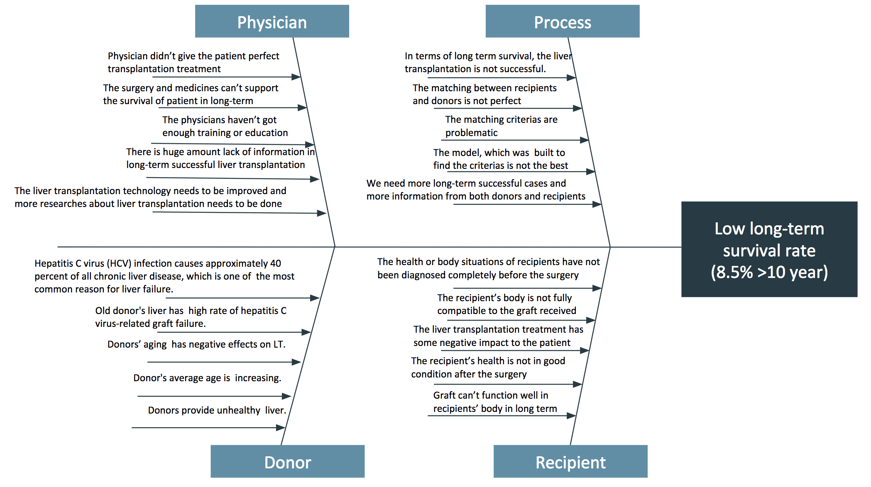

*Figure B1. Fishbone Diagram of analyzing long-term graft survival rate.*

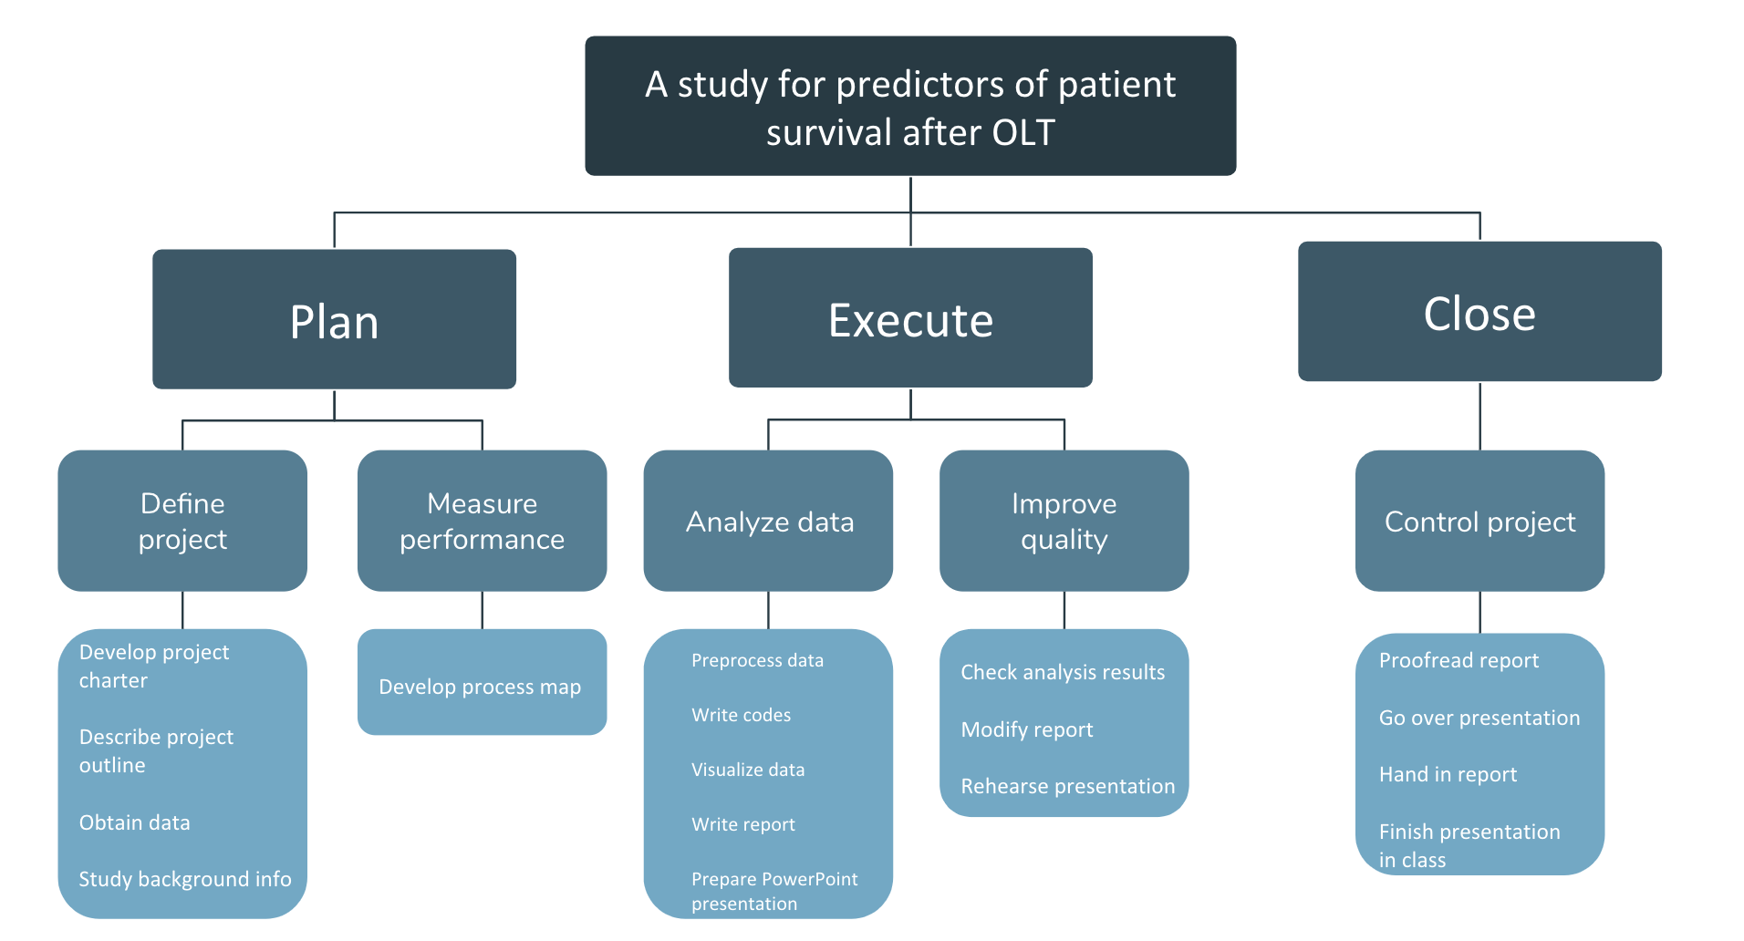

*Figure B2. Originally developed WBS for the tasks of the project.*

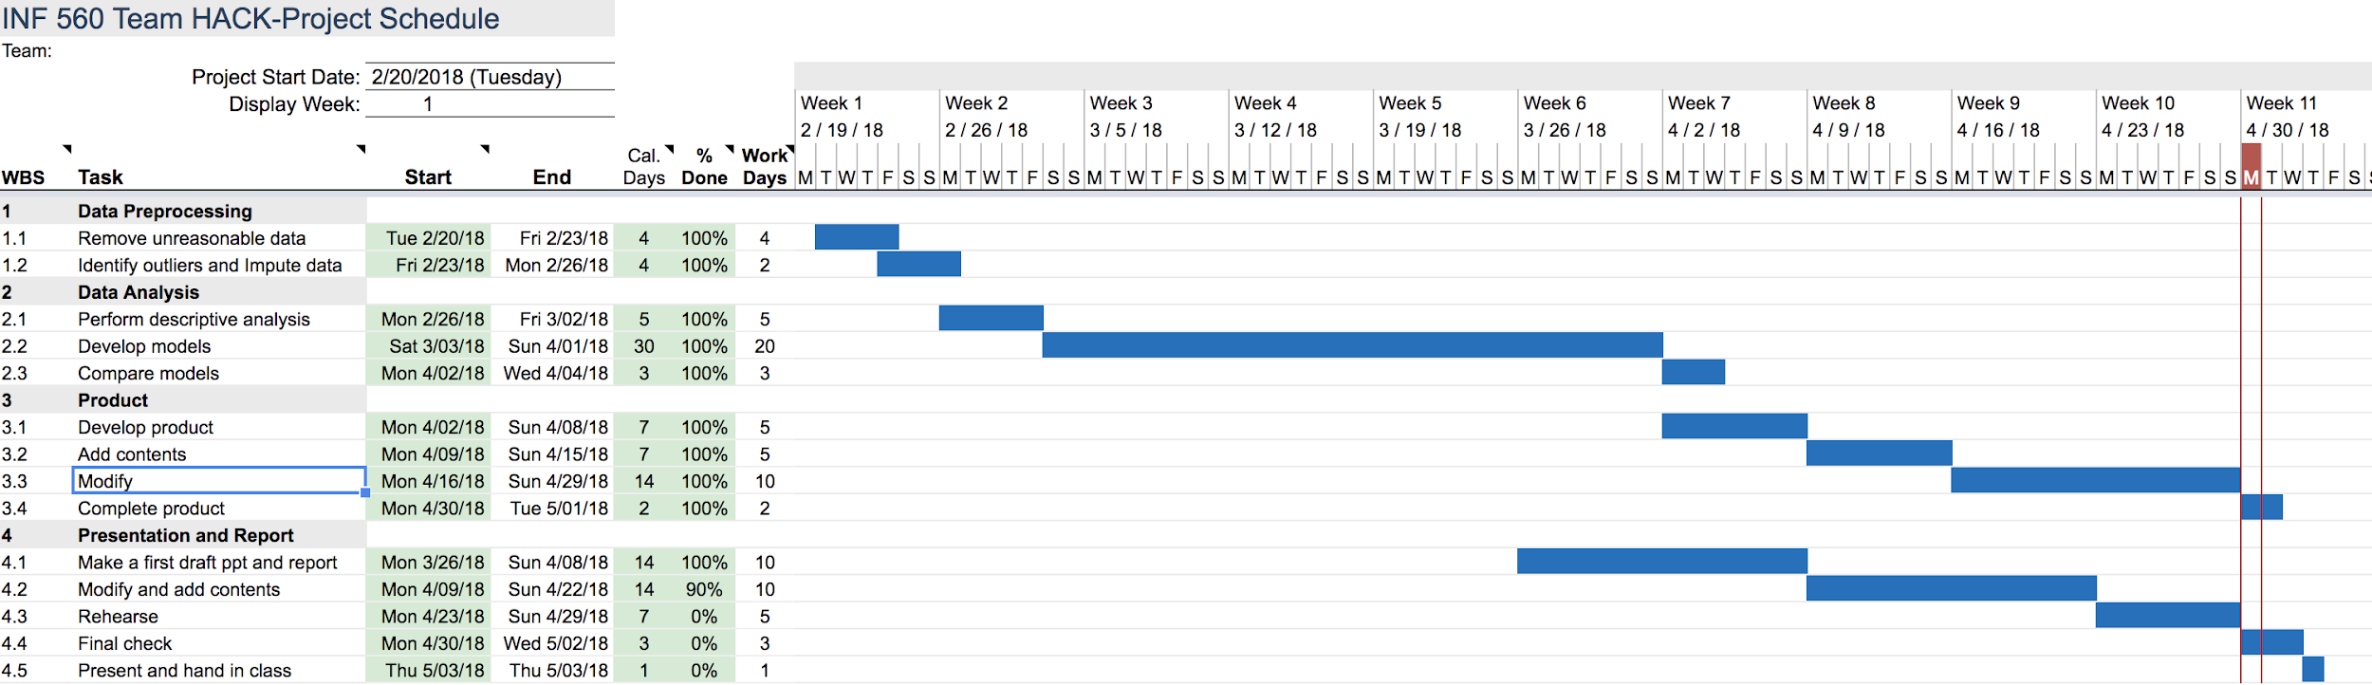

*Figure B3. Most recently updated Gantt Chart.*

**Appendix C**

**Graphs used in Data Exploration**

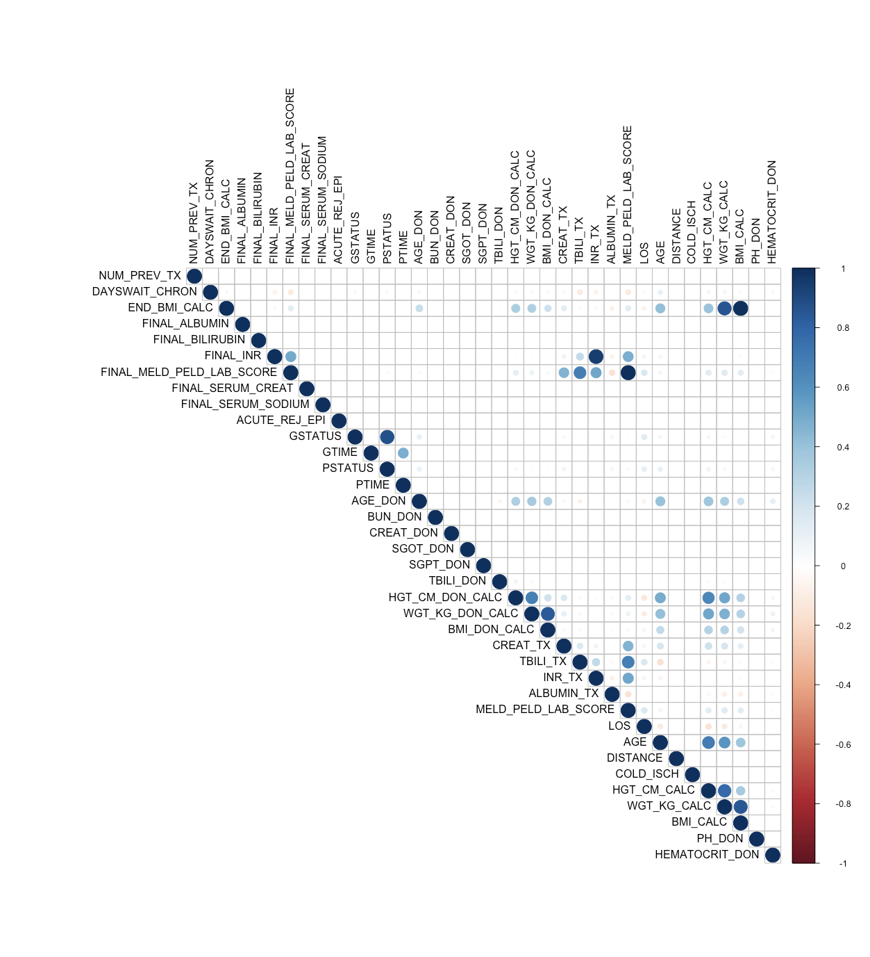

*Figure C1. Correlation matrix among continuous variables.*

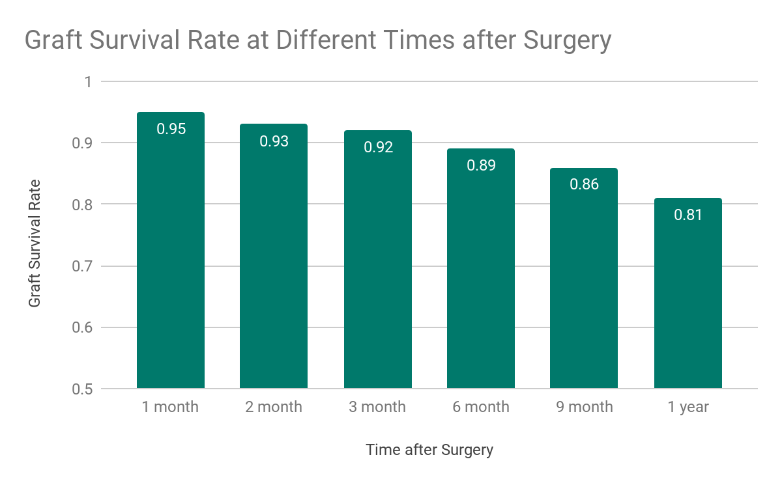

*Figure C2. Graft survival rate at different times after surgery.*

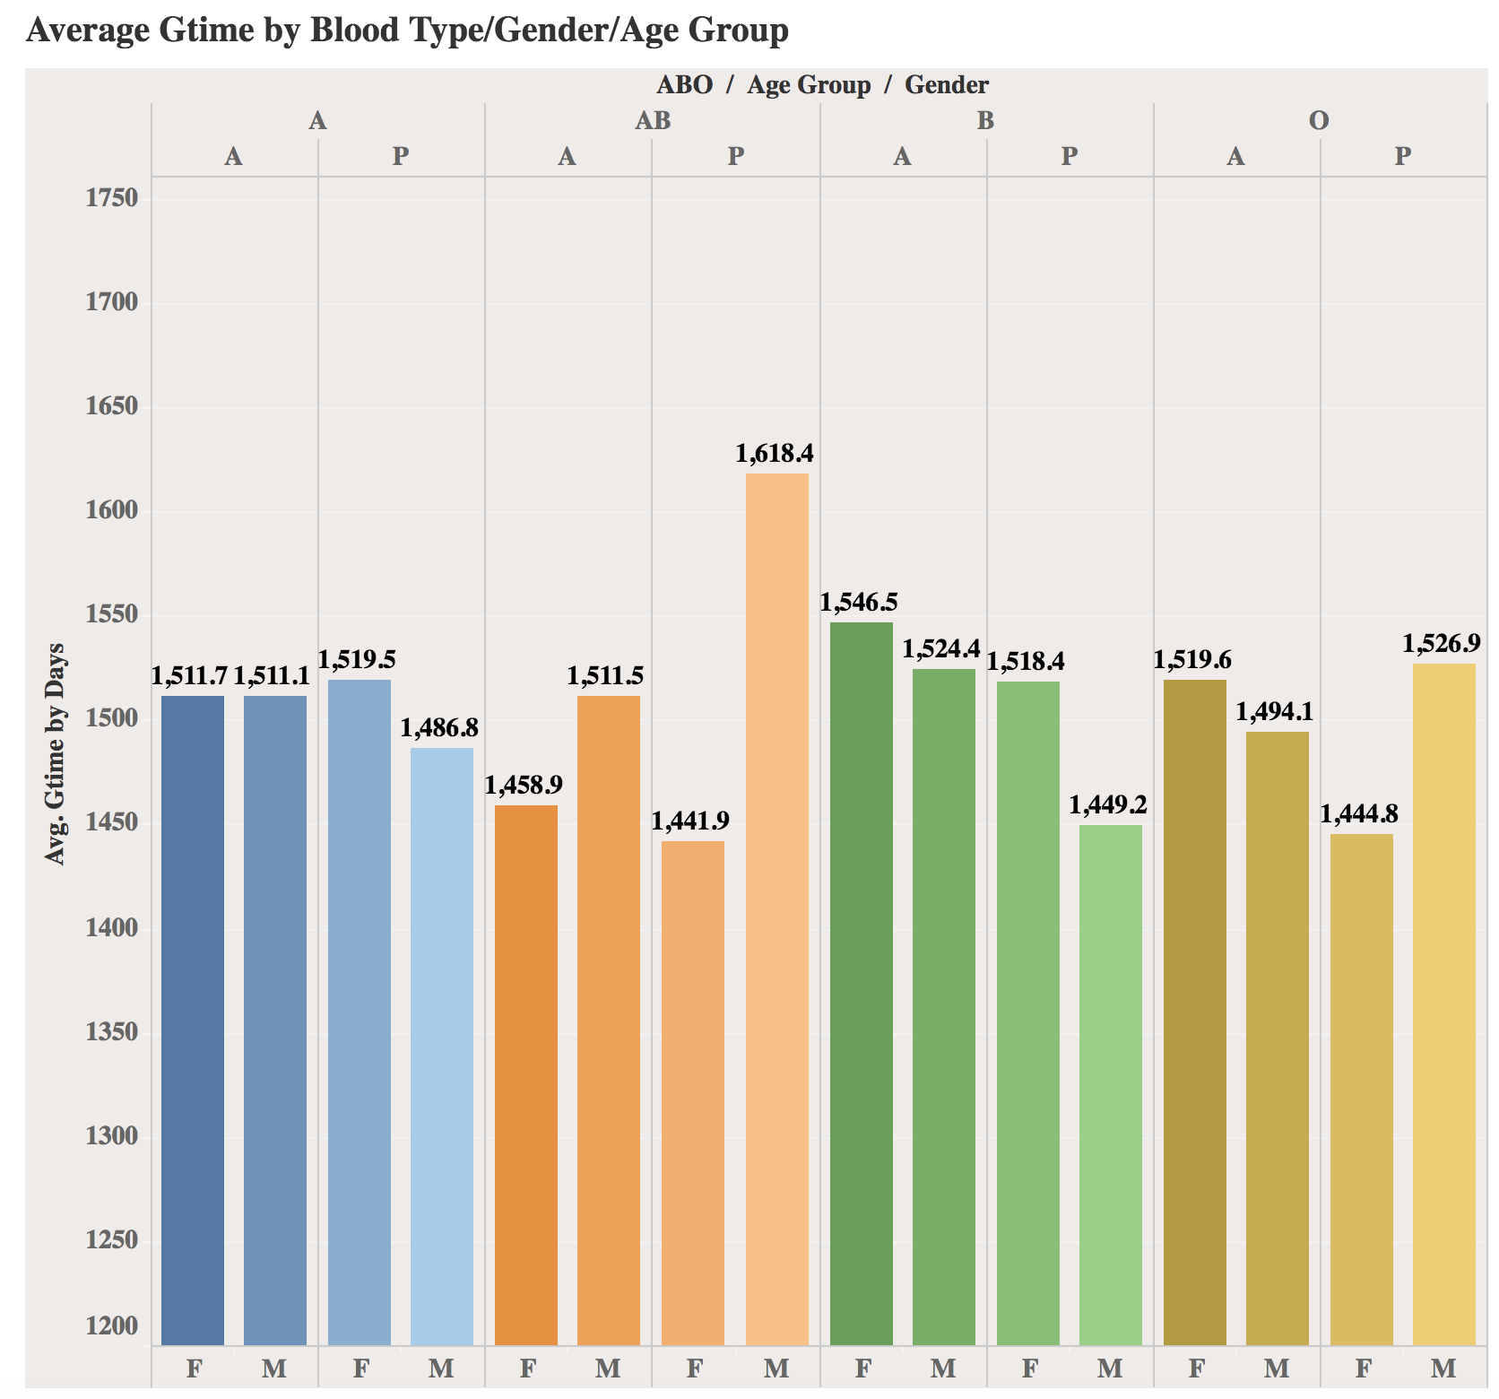

*Figure C3. Average graft survival time by ABO/Age group/Gender of recipient.*

**Appendix D**

**Variables Used in Different Models**

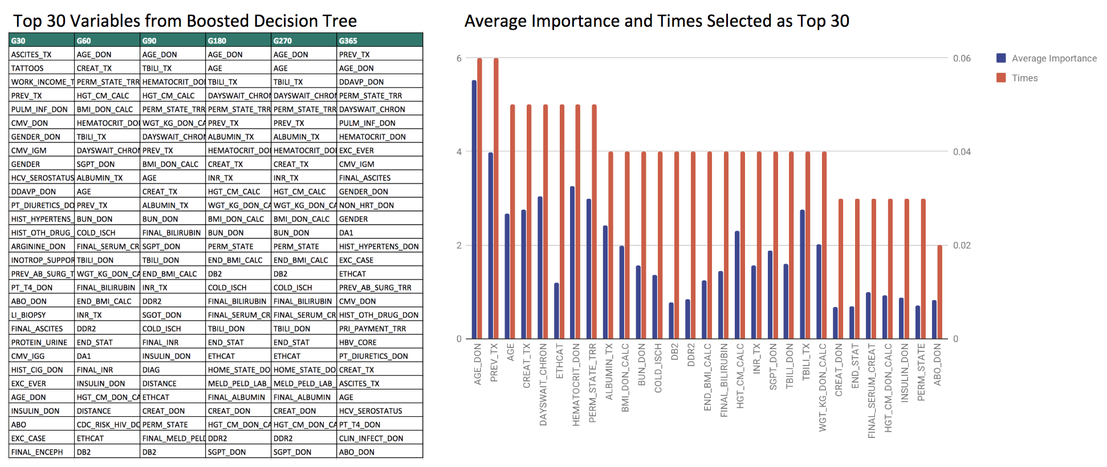

*Figure D1. Variables selected by boosted decision tree for classification (left); average importance score and the number of times selected for each of the top 30 variables (right).*

|  |  |
| --- | --- |
| **Selected Variables in Linear Regression** | **Estimate** |
| **Blood Type**  A  A1  A1B  A2  A2B  AB  B  O | -4.00  41.76  359.98  226.55  -31.09  -1.24  -12.26 |
| **Gender**  Male  Female | 1.28 |
| **Education**  1-None  2-Grade school (0-8)  3-High school (9-12)  4-Attended college/technical school  5-Associate/Bachelor degree  6-Post-college graduate degree  996-Less than 5 years  998-Unknown | -0.84  -0.89  -0.01 .  -0.93  -0.89  -0.85  -0.92 |
| **Diabetes**  1-No diabetes  2-Type 1  3-Type 2  4-Type other  5-Type unknown  998-Status unknown | 0.66 *  -0.11  -0.29  0.74  -0.45 |
| **Ethnicity**  1-White  2-Black  4-Hispanic  5-Asian  6-Amer Ind/Alaska Native  7-Native Hawaiian/other Pacific Islander  9-Multiracial | -4.07  -3.63  -1.57  6.66  90.34  40.42 |
| **BMI** | -1.40 * |
| **Number of Previous Transplantation** | 9.62 |
| **Days on liver waiting list** | -0.0077 |
| **Type of Exception Relative to HCC**  HBL  HCC  Non-HCC | 282.20  285.40 |
| **Region of Transplantation [11]**  1-Connecticut, Maine, Massachusetts, New Hampshire, Rhode Island, Eastern Vermont  2-Delaware, District of Columbia, Maryland, New Jersey, Pennsylvania, West Virginia, Northern Virginia  3-Alabama, Arkansas, Florida, Georgia, Louisiana, Mississippi, Puerto Rico  4-Oklahoma, Texas  5-Arizona, California, Nevada, New Mexico, Utah  6-Alaska, Hawaii, Idaho, Montana, Oregon, Washington  7-Illinois, Minnesota, North Dakota, South Dakota, Wisconsin  8-Colorado, Iowa, Kansas, Missouri, Nebraska, Wyoming  9-New York, Western Vermont  10-Indiana, Michigan, Ohio  11-Kentucky, North Carolina, South Carolina, Tennessee, Virginia | 6.76  24.34  1.63  42.24 .  42.45  50.00 .  -2.79  13.50  17.56  23.16 |
| **State of Residency at Registration**  AK-Alaska  AL-Alabama  AR-Arkansas  AS-American Samoa  AZ-Arizona  CA-California  CO-Colorado  CT-Connecticut  DC-District of Columbia  DE-Delaware  FL-Florida  GA-Georgia  GU-Guam  HI-Hawaii  IA-Iowa  ID-Idaho  IL-Illinois  IN-Indiana  KS-Kansas  KY-Kentucky  LA-Louisiana  MA-Massachusetts  MD-Maryland  ME-Maine  MI-Michigan  MN-Minnesota  MO-Missouri  MS-Mississippi  MT-Montana  NC-North Carolina  ND-North Dakota  NE-Nebraska  NH-New Hampshire  NJ-New Jersey  NM-New Mexico  NV-Nevada  NY-New York  OH-Ohio  OK-Oklahoma  OR-Oregon  PA-Pennsylvania  PR-Puerto Rico  RI-Rhode Island  SC-South Carolina  SD-South Dakota  TN-Tennessee  TX-Texas  UT-Utah  VA-Virginia  VI-Virgin Islands  VT-Vermont  WA-Washington  WI-Wisconsin  WV-West Virginia  WY-Wyoming  ZZ-Unknown | -74.89  -28.05  -149.40  -146.60  -112.00  -150.90  -68.85  -33.03  85.24  -97.46  -78.92  -410.00  -88.07  -74.26  29.85  -76.82  -162.70  -52.96  -102.2  -60.70  -104.4  -84.50  43.96  -129.7  -116.3  -88.85  -196.20  -62.58  -147.50  -229.20  -45.54  -78.09  -66.04  -18.41  -118.90  -98.82  -83.79  -73.99  -109.40  -93.32  -120.10  -128.00  -115.10  -42.67  -90.50  -78.23  -102.20  -120.90  -586.80  -124.40  -84.01  -81.49  -115.50  113.00  -167.10 |
| **Ascites**  1-Absent  2-Slight  3-Moderate  4-Unknown | -3.24  8.57  15.3 |
| **Bilirubin** | -0.14 |
| **Dialysis prior week**  Yes  No | -8.49 |
| **Encephy**  1-None  2-1 to 2  3- 3 to 4  4-Unknown | 15.56 .  16.50  53.58 * |
| **INR** | -2.81 |
| **Serum Creatinine** | 3.34 |
| **MELD or PELD Score** | -0.81 . |

*Figure D2. Variables selected by backward selection for linear regression. The symbol next to the coefficient estimate indicates the p-value of testing whether the estimate is zero. If the p-value is small, the test is significant and the estimate is said to not equal to zero and therefore there is significant relationship between the corresponding variable and GTIME*

*(0 ‘***’ 0.001 ‘**’ 0.01 ‘*’ 0.05 ‘.’ 0.1 ‘ ’ 1).*

|  |  |
| --- | --- |
| **Selected Variables in Cox Regression** | **Exponential of Coefficient Estimate** |
| **Recipient Age** | 1.00 *** |
| **Recipient Gender**  Male  Female | 0.094 |
| **Recipient Blood Type**  A  A1  A1B  A2  A2B  AB  B  O | 0.98  0.56  1.11  -0.000027  1.027  -0.95 .  1.04 * |
| **Recipient BMI** | 0.93 |
| **Recipient MELD/PELD Score** | 1.001 |
| **Previous Transplant**  Yes  No | 1.545 *** |
| **State of Residency Where Transplant will Take Place**  AK-Alaska  AL-Alabama  AR-Arkansas  AS-American Samoa  AZ-Arizona  CA-California  CO-Colorado  CT-Connecticut  DC-District of Columbia  DE-Delaware  FL-Florida  GA-Georgia  GU-Guam  HI-Hawaii  IA-Iowa  ID-Idaho  IL-Illinois  IN-Indiana  KS-Kansas  KY-Kentucky  LA-Louisiana  MA-Massachusetts  MD-Maryland  ME-Maine  MI-Michigan  MN-Minnesota  MO-Missouri  MP-Northern Mariana Islands  MS-Mississippi  MT-Montana  NC-North Carolina  ND-North Dakota  NE-Nebraska  NH-New Hampshire  NJ-New Jersey  NM-New Mexico  NV-Nevada  NY-New York  OH-Ohio  OK-Oklahoma  OR-Oregon  PA-Pennsylvania  PR-Puerto Rico  RI-Rhode Island  SC-South Carolina  SD-South Dakota  TN-Tennessee  TX-Texas  UT-Utah  VA-Virginia  VI-Virgin Islands  VT-Vermont  WA-Washington  WI-Wisconsin  WV-West Virginia  WY-Wyoming  ZZ-Unknown | 0.60  0.60  0.000055  0.62  0.57  0.59  0.62  0.66  0.63  0.67  0.59  0.98  0.44  0.61  0.51  0.69  0.82  0.67  0.74  0.66  0.62  0.71  0.85  0.75  0.61  0.65  0.000029  0.56 .  0.56  0.61  0.46 .  0.74  0.58 .  0.64  0.56 .  0.81  0.76  0.67  0.70  0.57 .  0.75  0.63  0.85  0.72  0.67  0.57 .  0.63  0.55 .  0.62  1.03  0.61  0.44 **  0.65  0.58 .  0.94  1.00 |
| **Days on Waiting List** | -0.998 *** |
| **Recipient Ethnicity**  1-White  2-Black  4-Hispanic  5-Asian  6-Amer Ind/Alaska Native  7-Native Hawaiian/other Pacific Islander  9-Multiracial | 1.05 .  1.09 **  1.08 .  0.87  0.89  1.10 |
| **Donor Age** | 1.009 *** |
| **Donor Gender**  Male  Female | 0.98 |
| **Donor Blood Type**  A  A1  A1B  A2  A2B  AB  B  O | 1.06  0.56  1.11  0.000027  1.03  0.95 .  1.04 * |
| **Donor BMI** | 0.78 *** |
| **Donor Type**  Deceased  Alive | 0.91 . |
| **Donor Hematocrit** | 1.01 *** |
| **Donor Less Than 7 Days Old at Time of Donation**  Yes  No | 7.88 ** |

*Figure D2. Variables used in cox regression. The symbol next to the coefficient estimate indicates the p-value of testing whether the estimate is zero. If the p-value is small, the test is significant and the estimate is said to not equal to zero and therefore there is significant relationship between the corresponding variable and graft survival (0 ‘***’ 0.001 ‘**’ 0.01 ‘*’ 0.05 ‘.’ 0.1 ‘ ’ 1).*

**Appendix E**

**More Details about Neural Network**

**a. The Target Function**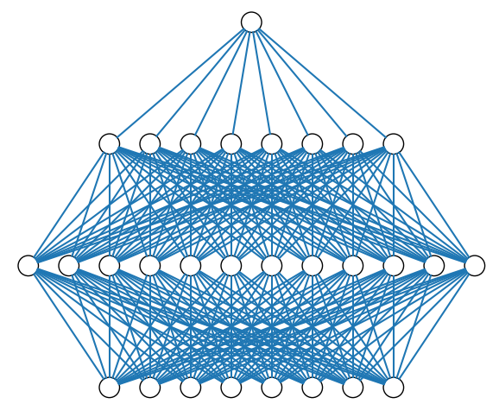

The target feature is GSTATUS, which is 0 or 1.

The input value $S^{(l)}$ of hidden layer can be obtained from equation: $S^{(l)}=W^{(l)}X^{(l-1)}+b^{(l)}, 1≤l≤L$

The output of sigmoid function can be calculated from equation: $X^{(l)}=sigmoid( S^{(l)})=\frac{1}{1+e^{- S^{(l)}}}, 1≤l≤L$

If the loss function is standard least square error, the error of output can be calculated as

Derivative of error for output layer is $δ^{(L)}=(X^{(L)}-y)(1-X^{(L)})X^{(L)}$

And for hidden layer, the derivative of error is ${δ_{i}}^{(l-1)}={x_{i}}^{(l-1)}(1-{x_{i}}^{(l-1)}) \sum_{j=0}^{d^{(l)}}{}{δ_{j}}^{(l)}{W_{i,j}}^{(l)}, 1≤l≤L-1$

Then update the weights and bias for output layer and hidden layer respectively:

${W_{i,j}}^{(l)}:={W_{i,j}}^{(l)}-α{δ_{j}}^{(l)}{x_{i}}^{(l-1)}, 1≤l≤L$

$b^{(l)}=b^{(l)}-ηδ^{(l)}, 1≤l≤L$

**b. Representation**

The input features of NN model can be any subsets of 145 features. For example, if we use 8 features among 145 features, the input layer structure is same to input layer structure in Figure E1, where the model has 8 input nodes.

### **c. System Structure**

We use 60 variables as inputs, so we have one input layer-60 input features, one hidden layer-12 neurons (activation function of hidden layer-sigmoid function), one hidden layer-9 neurons (activation function of hidden layer-sigmoid function), one hidden layer-8 neurons (activation function of hidden layer-sigmoid function), one hidden layer-8 neurons (activation function of hidden layer-sigmoid function), one hidden layer-7 neurons (activation function of hidden layer-sigmoid function) and one output layer (activation function of output layer-sigmoid function. In this structure, there are 200 unknown variables. Between input layer and first hidden layer, there are 96 unknown variables. Between first hidden layer and second hidden layer, there are 96 variables. From the second layer to output layer, there are 8 variables.

### **d. The Learning Algorithm**

After finishing data preprocessing, we set input features and target output. With the pseudo code of NN Model.1, if we use 60 features, dimension of each input data is 60. After computing $x^{(1)}$ in forward direction, we have 12-dimension input data, $x^{(2)}$. This calculation uses the first part of pseudocode. Then if we compute $x^{(2)}$ in forward direction again, we can get $x^{(3)}$, which is 9 dimensions. Finally, after computing $x^{(6)}$ in forward direction, we can get one-dimension output value of this model. From the error, we need to calculate $δ$ from output layer to input layer. When we update weights, it should be updated from input layer to output layer. To make this learning process efficient, we use ADAM optimizer. We train and test model with 100 batch sizes and 100 numbers of epoch. The learning rate of ADAM is 0.01.[12]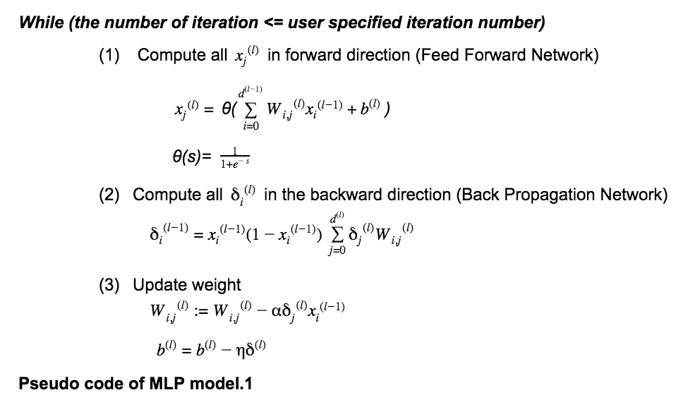

### **e. Improvements and Modifications**

To improve our NN model, we have considered different structures of NN, activation function, numbers of epoch, batch size and optimizers. It was examined and the result shows that epoch number 300, batch size 200, and ADAM optimizer 0.01 give best model accuracy.

**Appendix F**

**More Details about Support Vector Machine**

**a. The Target Function**

The target feature is graft survival status, labeled with 6 categories in 1 month, 2 months, 3 months, 6 months, 9 months, and 1 year. The input features of model are selected from boosted decision tree. The output of SVM model is 0 or 1 in each graft survival label.

If we use kernel function ψ((a, b))=(a, b, $a^{2}+b^{2}$), the i-th row and j-th column of Q matrix is $Y_{j}Y_{j}K(X_{i},X_{j})$, where $X_{i}$ means each values of each variable and 20-dimension coordinates of each data point in our model. $Y_{i}$ represents the label of each graft status, valuing 1 or 0. Because the kernel function is

*ψ((a, b))=(a, b, $a^{2}+b^{2}$), $K(X_{i},X_{j})$ is ${X_{i}}^{T}X_{j}+{{(X}_{i}}^{T}X_{i})({X_{j}}^{T}X_{j})$.*

${Max}_{α}\sum_{n=1}^{N}{}α_{n}-1/2α^{T}Qα$*(1)*

*Such that for all n, $α_{n}≥0$, $\sum_{n=1}^{N}{}α_{n}y_{n}=0$* .

After performing the steps above, we can get W by using $α$ by W = $\sum_{n=1}^{N}{}α_{n}y_{n}{z_{i}}^{T}$, where $z_{i}$ is the nonlinear transformation of $X_{i}$. In this case, W is 1 by 3 vector and z is 3 by 1 vector, because if x is (a, b), the nonlinear transformation of x, ψ((a, b)), is (a, b, $a^{2}+b^{2}$), which is in z space. Finally, we can obtain get b from the equation (2).

+ (2)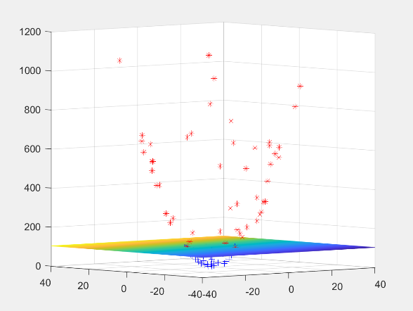

**b. Representation**

The input features of SVM model can be subsets of 145 features. For example, if we only use 2 features among 145 features, each data points and the SVM model can be plotted like the Figure F1.

**c. System Structure**

For the SVM model, we have one input 20-dimension input features. Each dimension presents each data field which was selected by boosted decision tree from original data set. The kernel is Radial basis function. The gamma value is 10. [13]

**Appendix G**

**Assessing Assumptions of Linear Regression**

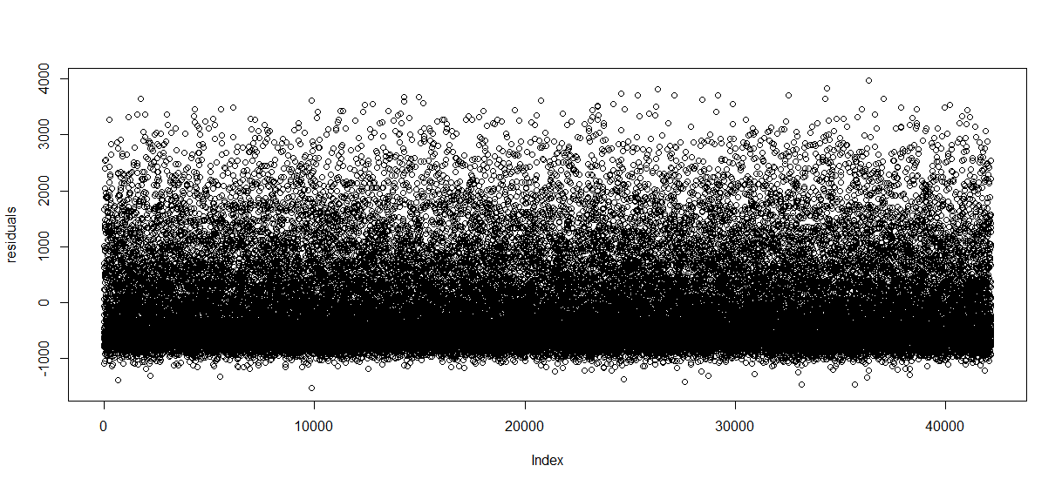

*Figure G1. Residual plot of linear regression model, showing violation of linearity and homoscedasticity. Plot meeting the assumptions should show equal variance above and below 0 across all values on the x-axis.*

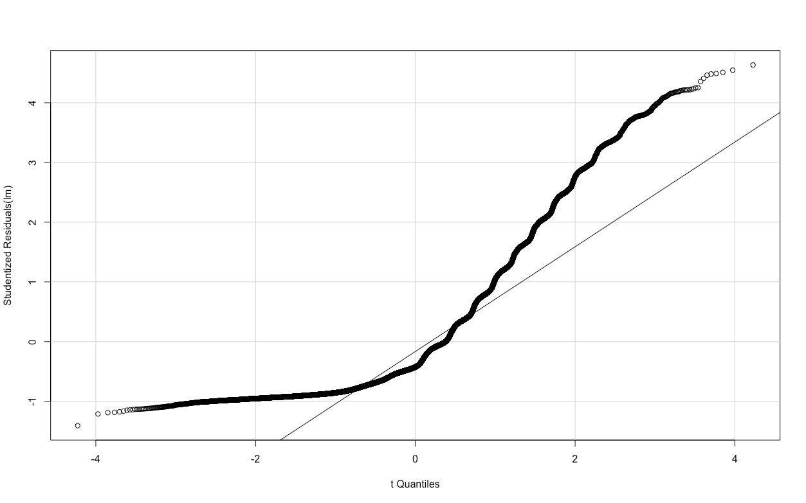

*Figure G2. Q-Q plot of linear regression model, showing violation of normality. Plot meeting the assumption should show scatter point closely aligning with the solid line.*

**Appendix H**

**Assessing Assumption of Cox Regression**

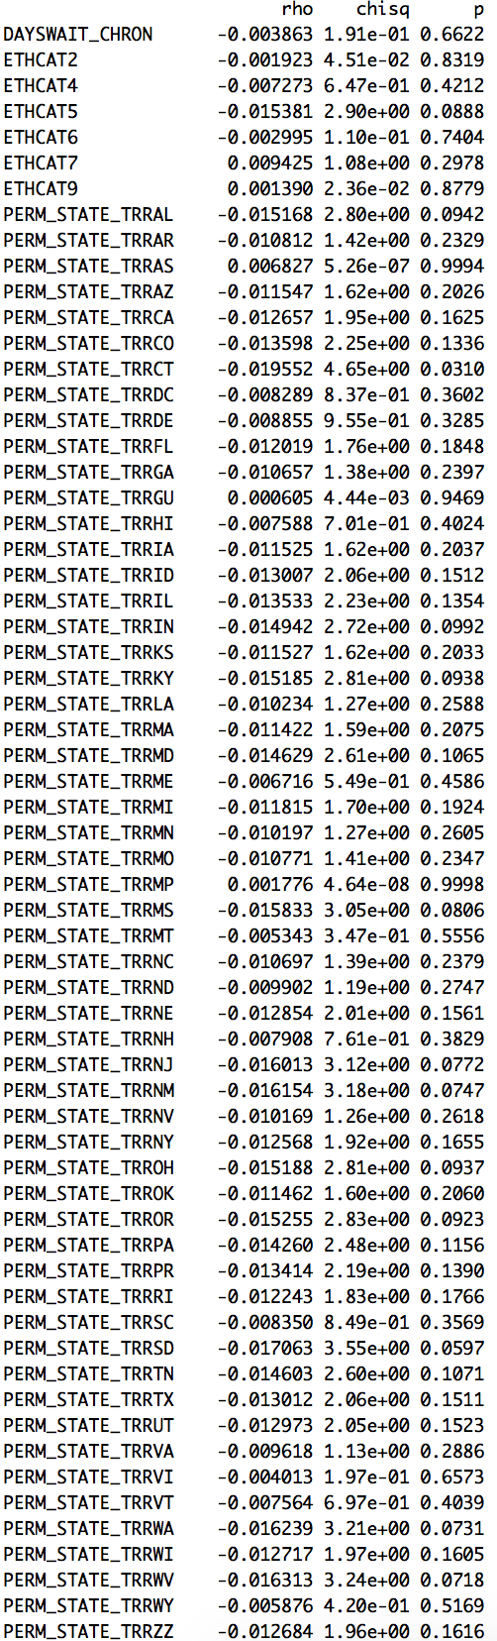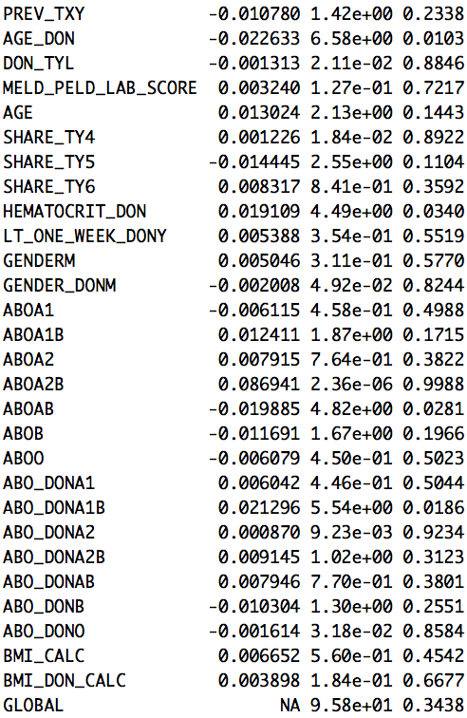

*Figure H1. Outputs of testing proportional hazard assumption. P value less than 0.05 indicates violation of the assumption.*

**Reference**

1. “Liver Disease Information.” *American Liver Foundation*, [www.liverfoundation.org/](http://www.liverfoundation.org/).

2. Kim, W. R., et al. “OPTN/SRTR 2012 Annual Data Report: Liver.” American Journal of Transplantation, vol. 14, no. S1, 2014, pp. 69–96., doi:10.1111/ajt.12581.

3. Masconi, Katya L, et al. “Reporting and Handling of Missing Data in Predictive Research for Prevalent Undiagnosed Type 2 Diabetes Mellitus: a Systematic Review.” *EPMA Journal*, vol. 6, no. 1, Nov. 2015, doi:10.1186/s13167-015-0028-0.

4. “Measurement System Analysis (MSA).” MoreSteam Lean Six Sigma Training and Technology, [www.moresteam.com/toolbox/measurement-system-analysis.cfm](http://www.moresteam.com/toolbox/measurement-system-analysis.cfm).

5. Schrem, Harald, et al. “Value and Limitations of the BAR-Score for Donor Allocation in Liver Transplantation.” Langenbeck's Archives of Surgery, vol. 399, no. 8, 2014, pp. 1011–1019., doi:10.1007/s00423-014-1247-x.

6. “Epoch vs Iteration When Training Neural Networks.” Terminology - Epoch vs Iteration When Training Neural Networks - Stack Overflow, stackoverflow.com/questions/4752626/epoch-vs-iteration-when-training-neural-networks?utm_medium=organic&utm_source=google_rich_qa&utm_campaign=google_rich_qa.

7. Patel, Savan. “Chapter 2 : SVM (Support Vector Machine) - Theory – Machine Learning 101 – Medium.” Medium, Machine Learning 101, 3 May 2017, medium.com/machine-learning-101/chapter-2-svm-support-vector-machine-theory-f0812effc72.

8. “Kernel Method.” *Wikipedia*, Wikimedia Foundation, 27 Apr. 2018, en.wikipedia.org/wiki/Kernel_method.

9. “RBF SVM Parameters.” RBF SVM Parameters - Scikit-Learn 0.19.1 Documentation, scikit-learn.org/stable/auto_examples/svm/plot_rbf_parameters.html.

10. Chen, Zehua. “Interpretation of proportional hazards regression models.” ST3242 Notes. <https://www.stat.nus.edu.sg/~stachenz/ST3242Notes4.pdf>

11. “Organ Procurement and Transplantation Network.” *Regions - OPTN*, optn.transplant.hrsa.gov/members/regions/.

12. Goodfellow, Ian, et al. *Deep Learning*. Aaron Courville Online Book, 2017.

13. Ng, Andrew. “CS229 Lecture notes.” <https://see.stanford.edu/materials/aimlcs229/cs229-notes3.pdf>